**Lab 3. Joins and Subqueries**

**1. Write a query which displays Staff Name, Department Code, Department Name,**

**and Salary for all staff who earns more than 20000.**

SELECT S.STAFF_NAME, S.DEPT_CODE, D.DEPT_NAME, S.STAFF_SAL FROM STAFF_MASTERS, DEPARTMENT_MASTER D WHERE S.DEPT_CODE=D.DEPT_CODE AND S.STAFF_SAL>20000;

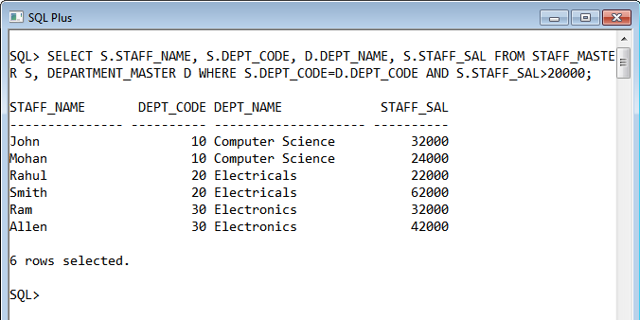

**2. Write a query to display Staff Name, Department Code, and Department Name for**

**all staff who do not work in Department code 10 and have ‘A’ in their name.**

SELECT S.STAFF_NAME, S.DEPT_CODE, D.DEPT_NAME FROM STAFF_MASTER S, DEPARTMENT_MASTER D WHERE S.DEPT_CODE=D.DEPT_CODE AND S.DEPT_CODE!=10 AND S.STAFF_NAME LIKE ('%A%');

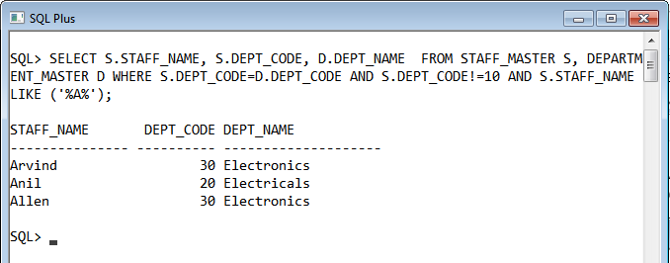

**3. Display Staff Code, Staff Name, Department Name, and his manager’s number and**

**name. Label the columns Staff#, Staff, Mgr#, Manager.**

SELECT S1.STAFF_CODE,S1.STAFF_NAME,S2.DESIGN_NAME,S1.MGR_CODE,(SELECT STAFF_NAME FROM STAFF_MASTER WHERE S1.MGR_CODE=STAFF_CODE)AS "MANAGER NAME" FROM STAFF_MASTER S1,DESIGNATION_MASTER S2 WHERE S1.DESIGN_CODE=S2.DESIGN_CODE;

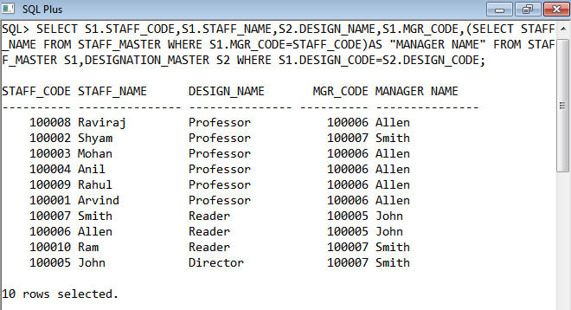

**4. Create a query that will display Student Code, Student Name, Department Name,**

**Subject1, Subject2, and Subject3 for all students who are getting 60 and above in each**

**subject from department 10 and 20.**

SELECT S1.STUDENT_CODE,S1.STUDENT_NAME,S1.DEPT_CODE,S3.DEPT_NAME,S2.SUBJECT1,S2.SUBJECT2,S2.SUBJECT3 FROM STUDENT_MASTER S1,STUDENT_MARKS S2,DEPARTMENT_MASTER S3 WHERE S1.STUDENT_CODE=S2.STUDENT_CODE AND S1.DEPT_CODE=S3.DEPT_CODE AND S2.SUBJECT1>60 AND S2.SUBJECT2>60 AND S2.SUBJECT3>60 AND S1.DEPT_CODE IN (10,20) AND S2.STUDENT_YEAR=2011;

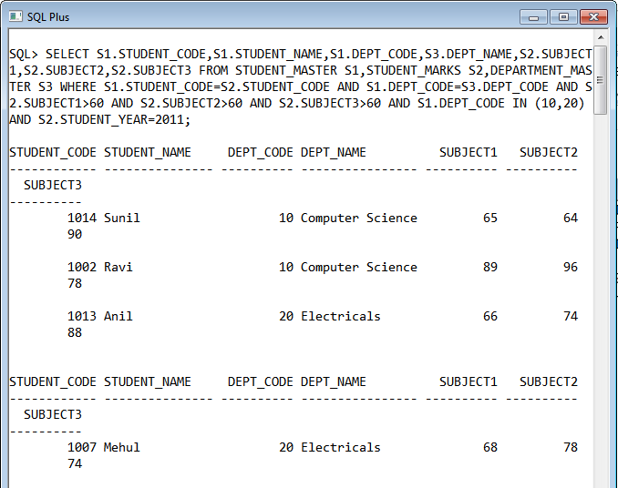

**5. Create a query that will display Student Code, Student Name, Book Code, and**

**Book Name for all students whose expected book return date is today.**

SELECT B1.STUDENT_CODE,B2.STUDENT_NAME,B1.BOOK_CODE,B3.BOOK_NAME FROM BOOK_TRANSACTIONS B1,STUDENT_MASTER B2 ,BOOK_MASTER B3 WHERE B1.BOOK_CODE=B3.BOOK_CODE AND B1.STUDENT_CODE=B2.STUDENT_CODE;

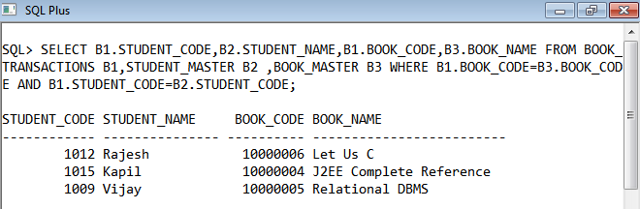

**6. Create a query that will display Staff Code, Staff Name, Department Name,**

**Designation, Book Code, Book Name, and Issue Date. For only those staff who have**

**taken any book in last 30 days.**

SQL> SELECT B1.STAFF_CODE,B2.STAFF_NAME,B4.DEPT_NAME,B5.DESIGN_NAME,B1.BOOK_CODE,B3.BOOK_NAME,B1.BOOK_ISSUE_DATE FROM BOOK_TRANSACTIONS B1,STAFF_MASTER B2 ,BOOK_MASTER B3,DEPARTMENT_MASTER B4,DESIGNATION_MASTER B5 WHERE B1.BOOK_CODE=B3.BOOK_CODE AND B1.STAFF_CODE=B2.STAFF_CODE AND B2.DEPT_CODE=B4.DEPT_CODE AND B2.DESIGN_CODE=B5.DESIGN_CODE;

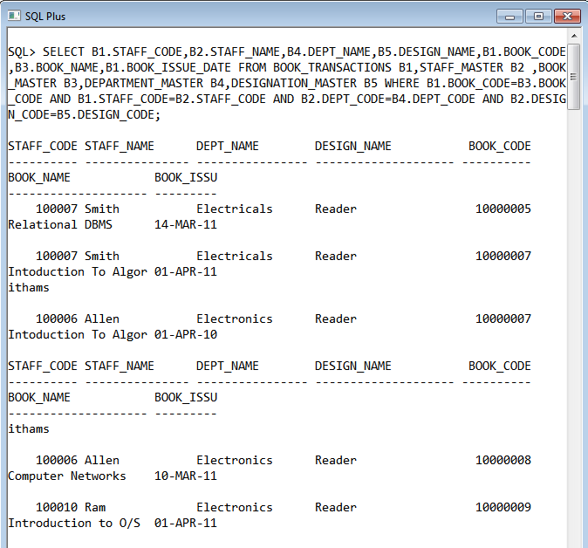

**7. Generate a report which contains the following information.**

**Staff Code Staff Name Designation Department Name Department Head**

**For all staff excluding HOD (List should not contain the details of Department head).**

SQL> SELECT S1.STAFF_CODE,S1.STAFF_NAME,S2.DESIGN_NAME,S3.DEPT_NAME FROM STAFF_MASTER S1,DESIGNATION_MASTER S2,DEPARTMENT_MASTER S3 WHERE S1.DESIGN_CODE=S2.DESIGN_CODE AND S1.DEPT_CODE=S3.DEPT_CODE AND S2.DESIGN_NAME!='HOD';

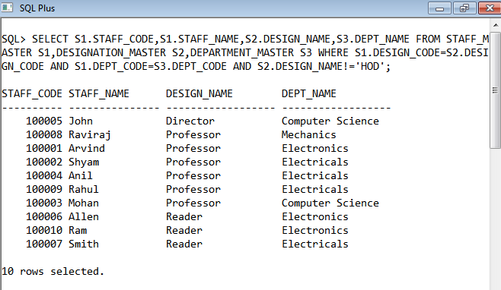

**8. Generate a report which contains the following information**

**Student Code Student Name Department Name Total Marks**

**HOD Name**

**Sort the output on Department Name and Total Marks.**

SELECT S1.STUDENT_CODE,S1.STUDENT_NAME,S2.DEPT_NAME,S3.SUBJECT1+S3.SUBJECT2+S3.SUBJECT3 AS "TOTAL MARKS" FROM STUDENT_MASTER S1,DEPARTMENT_MASTER S2,STUDENT_MARKS S3 WHERE S1.DEPT_CODE=S2.DEPT_CODE AND S3.STUDENT_YEAR=2011 AND S1.STUDENT_CODE=S3.STUDENT_CODE ORDER BY S2.DEPT_NAME,"TOTAL MARKS";

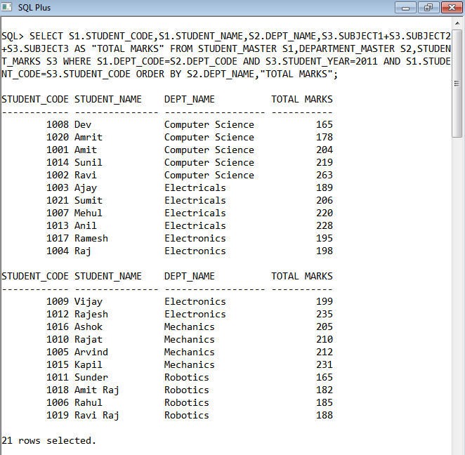

**9. Generate a report which contains the following information.**

**Staff Code, Staff Name, Designation, Department, Book Code, Book Name,**

**Author, Fine**

**For the staff who have not return the book. Fine will be calculated as Rs. 5 per day.**

**Fine = 5 * (No. of days = Current Date – Expected return date).**

SELECT B1.STAFF_CODE,B2.STAFF_NAME,B3.DESIGN_NAME,B4.DEPT_NAME,B1.BOOK_CODE,B5.BOOK_NAME,5*ROUND(SYSDATE-B1.BOOK_EXPECTED_RETURN_DATE) AS "FINE" FROM BOOK_TRANSACTIONS B1,STAFF_MASTER B2,DESIGNATION_MASTER B3,DEPARTMENT_MASTER B4,BOOK_MASTER B5 WHERE B1.STAFF_CODE=B2.STAFF_CODE AND B2.DESIGN_CODE=B3.DESIGN_CODE AN D B2.DEPT_CODE=B4.DEPT_CODE AND B1.BOOK_CODE=B5.BOOK_CODE;

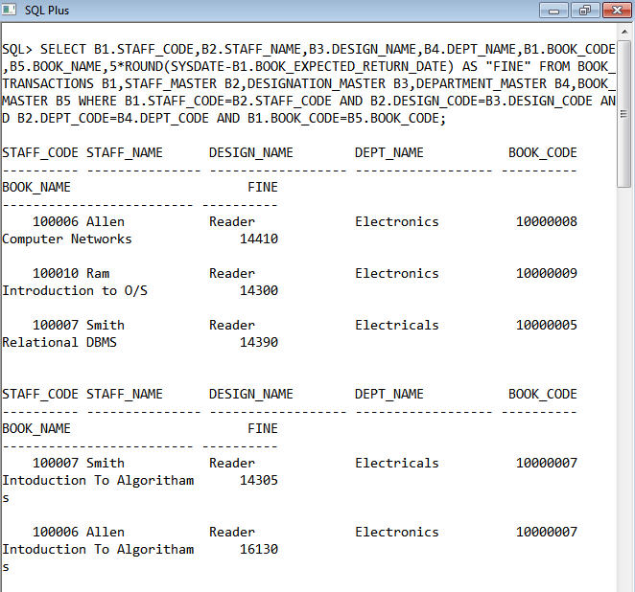

**10. List Staff Code, Staff Name, and Salary for those who are getting less than the**

**average salary of organization.**

SELECT STAFF_CODE,STAFF_NAME,STAFF_SAL FROM STAFF_MASTER WHERE STAFF_SAL<(SELECT AVG(STAFF_SAL) FROM STAFF_MASTER);

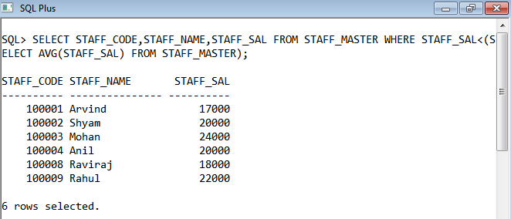

**11. List the Staff Code, Staff Name who are not Manager.**

SELECT STAFF_CODE,STAFF_NAME FROM STAFF_MASTER WHERE STAFF_CODE NOT IN (SELECT MGR_CODE FROM STAFF_MASTER);

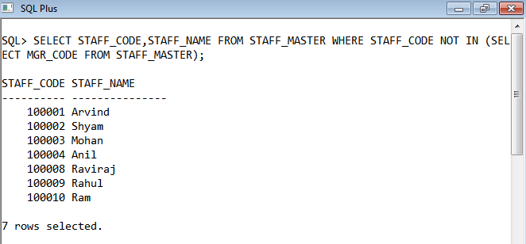

**12. Display Author Name, Book Name for those authors who wrote more than one**

**book.**

SELECT BOOK_PUB_AUTHOR,BOOK_NAME FROM BOOK_MASTER WHERE BOOK_PUB_AUTHOR IN(SELECT BOOK_PUB_AUTHOR FROM BOOK_MASTER GROUP BY BOOK_PUB_AUTHOR HAVING COUNT(*)>1);

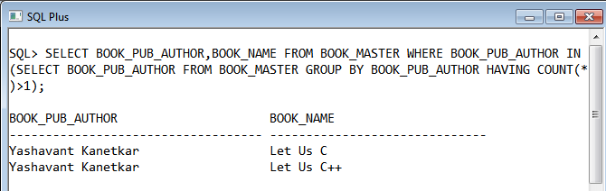

**13. Display Staff Code, Staff Name, and Department Name for those who have taken**

**more than one book.**

SELECT S1.STAFF_CODE,S2.STAFF_NAME,S3.DEPT_NAME FROM BOOK_TRANSACTIONS S1,STAFF_MASTER S2,DEPARTMENT_MASTER S3 WHERE S1.STAFF_CODE IN (SELECT STAFF_CODE FROM BOOK_TRANSACTIONS GROUP BY STAFF_CODE HAVING COUNT(*)>1) AND S1.STAFF_CODE=S2.STAFF_CODE AND S2.DEPT_CODE=S3.DEPT_CODE;

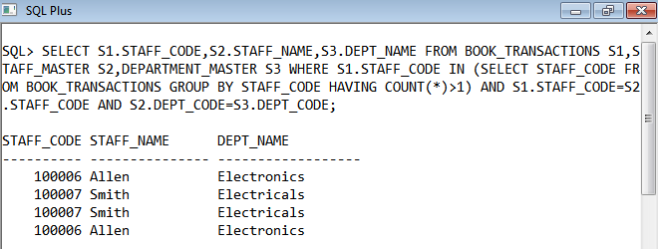

**14. Display top ten students for a specified department. Details are:**

**Student Code, Student Name, Department Name, Subject1, Subject2,**

**Subject3, Total.**

SQL> SELECT STUDENT_MARKS.STUDENT_CODE, STUDENT_NAME, DEPT_NAME, SUBJECT1, SUBJECT2, SUBJECT3, SUBJECT1+SUBJECT2+SUBJECT3 AS TOTAL, &DEPT_CODE FROM STUDENT_MASTER, DEPARTMENT_MASTER, STUDENT_MARKS WHERE STUDENT_MASTER.STUDENT_CODE=STUDENT_MARKS.STUDENT_CODE AND DEPARTMENT_MASTER.DEPT_CODE=STUDENT_MASTER.DEPT_CODE AND R

OWNUM <=10 ORDER BY TOTAL;

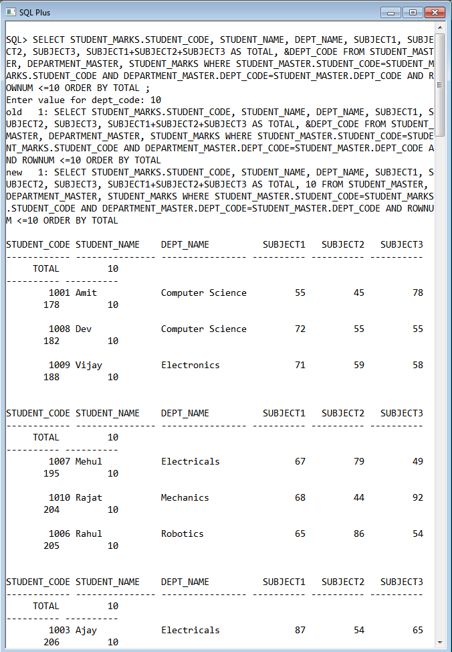

**15. Display the Staff Name, Department Name, and Salary for those staff who are**

**getting less than average salary in their own department**

SELECT STAFF_NAME, DEPT_NAME FROM STAFF_MASTER, DEPARTMENT_MASTER WHERE STAFF_MASTER.DEPT_CODE=DEPARTMENT_MASTER.DEPT_CODE AND STAFF_SAL<(SELECT AVG(STAFF_SAL) FROM STAFF_MASTER);

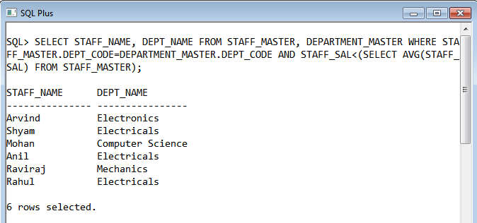

**16. Create a query that will display the Staff Name, Department Name, and all the**

**staff that work in the same department as a given staff. Give the column as**

**appropriate label.**

SELECT DISTINCT STAFF_NAME, DEPT_NAME FROM STAFF_MASTER, DEPARTMENT_MASTER WHERE STAFF_MASTER.DEPT_CODE=DEPARTMENT_MASTER.DEPT_CODE ORDER BY DEPT_NAME;

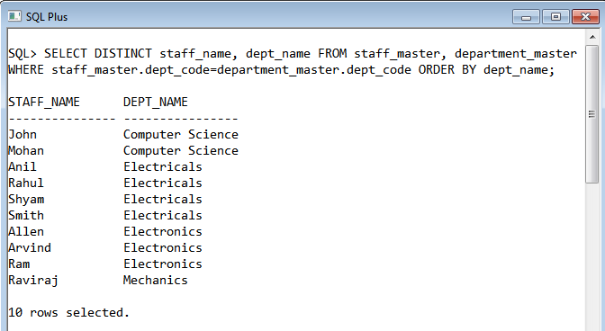

**17. List the Student Code, Student Name for that student who got highest marks in all three subjects in Computer Science department for current year.**

SELECT STUDENT_MASTER.STUDENT_CODE, STUDENT_NAME FROM STUDENT_MASTER, STUDENT_MARKS WHERE STUDENT_MASTER.STUDENT_CODE=STUDENT_MARKS.STUDENT_CODE AND DEPT_CODE IN(SELECT DEPT_CODE FROM DEPARTMENT_MASTER WHERE DEPT_NAME='Computer Science') AND SUBJECT1+SUBJECT2+SUBJECT3=(SELECT MAX(SUBJECT1+SUBJECT2+SUBJECT3) FROM STUDENT_MARKS WHERE STUDENT_YEAR=&STUDENT_YEAR);

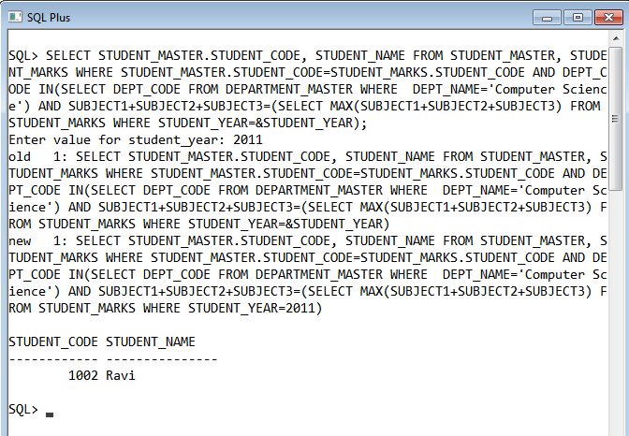

**18. Display the Student Code, Student Name, and Department Name for that department in which there are maximum number of student are studying.**

SELECT STUDENT_CODE, STUDENT_NAME, DEPT_NAME FROM STUDENT_MASTER, DEPARTMENT_MASTER WHERE STUDENT_MASTER.DEPT_CODE=DEPARTMENT_MASTER.DEPT_CODE AND STUDENT_MASTER.DEPT_CODE IN (SELECT * FROM (SELECT DEPT_CODE FROM STUDENT_MASTER GROUP BY DEPT_CODE ORDER BY COUNT(DEPT_CODE) DESC )WHERE ROWNUM = 1);

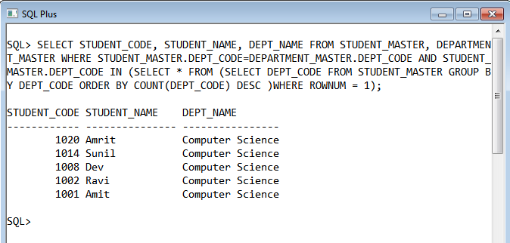

**19. Display Staff Code, Staff Name, Department Name, and Designation for those**

**who have joined most recently.**

SELECT STAFF_CODE, STAFF_NAME, DEPT_NAME, DESIGN_NAME FROM STAFF_MASTER S, DEPARTMENT_MASTER D, DESIGNATION_MASTER DES WHERE S.DEPT_CODE=D.DEPT_CODE AND S.DESIGN_CODE=DES.DESIGN_CODE AND SYSDATE-HIREDATE<=30;

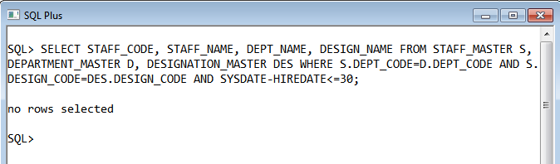

**20. Display the Manager Name and the total strength of his/her team.**

SELECT M.STAFF_NAME "MANAGER", COUNT(S.STAFF_CODE) "NO. OF SUBORDINATES" FROM STAFF_MASTER M, STAFF_MASTER S WHERE S.MGR_CODE=M.STAFF_CODE GROUP BY M.STAFF_NAME;

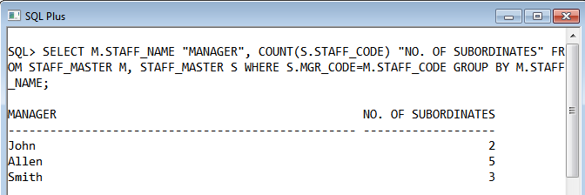

**21. Get the details of all products irrespective of the fact whether they are in previous**

**set or current set.**

SELECT * FROM PREVIOUS_PRODUCTS UNION SELECT * FROM CURRENT_PRODUCTS;

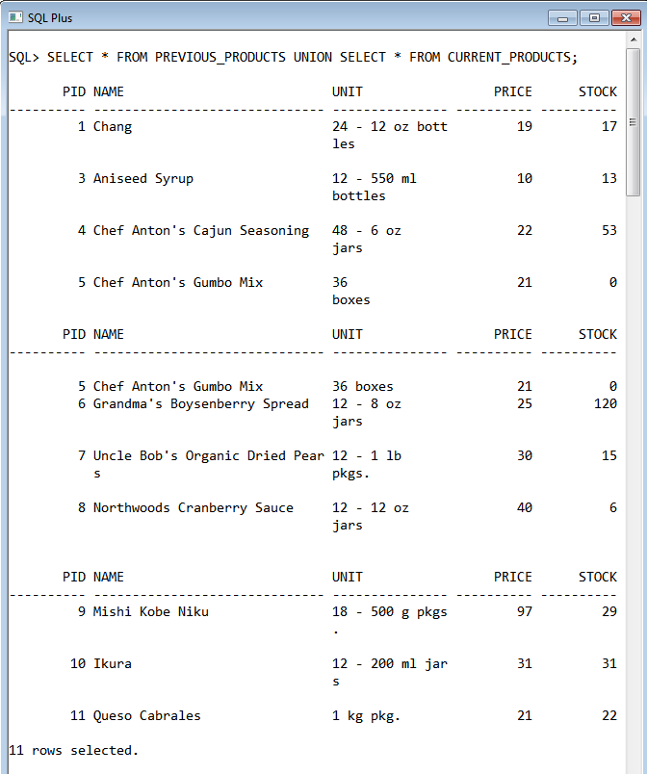

**22. Get the details of all products along with the repetition of those that were present**

**both in the previous and current sets.**

SELECT * FROM PREVIOUS_PRODUCTS UNION ALL SELECT * FROM CURRENT_PRODUCTS;

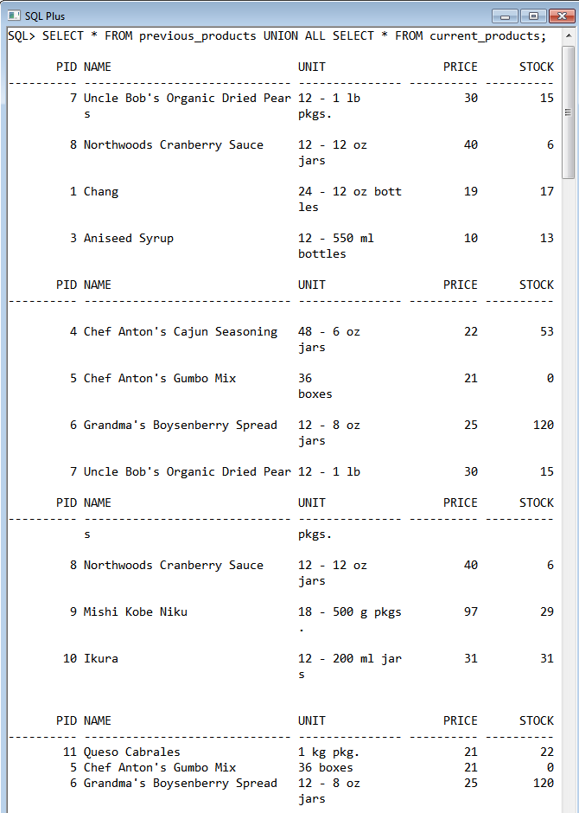

**23. Get the details of only those products which were present in the previous set and**

**are still continuing.**

SELECT * FROM PREVIOUS_PRODUCTS INTERSECT SELECT * FROM CURRENT_PRODUCTS;

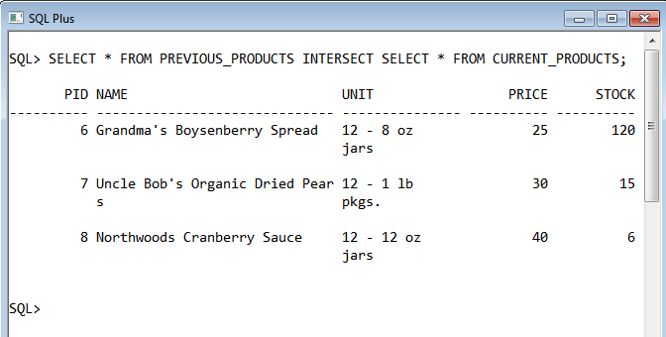

**24. Get the details of all obsolete products (no longer continued).**

SELECT * FROM PREVIOUS_PRODUCTS MINUS SELECT * FROM CURRENT_PRODUCTS;

